

**UNIVERSITY OF NAIROBI**

**CSC 416 4th Year Project Proposal**

**University of Nairobi**

**School of Computing and Informatics**

**By**

Name: **THON PETER MAWUT**

Registration No: **P15/137741/2019**

Project title: **Decentralized Students e-Voting System with Blockchain**

Supervisor: **Dr.Michaelina Almaz Yohannis**

**Year: 2023-2024**

Contents

CHAPTER 1: INTRODUCTION 2

1.1 Overview 2

1.2 Background 2

1.3 Problem Statement 2

1.4 Proposed Solution 3

1.4.1 Key Components 3

1.4.2 Expected Outcomes 3

1.4 Why I Chose This Project 4

1.5 Objectives 4

1.6 Research Objectives 4

1.7 Research topics 4

1.8. Business Requirements 6

1.9 Tools 7

1.10 Scope and Limitations 7

1.10.1 In Scope 7

1.10.2 Out of Scope 7

CHAPTER 2: LITERATURE REVIEW 9

2.1 Introduction 9

2.2 Lessons from Kenya's National Elections 9

2.3 E-Voting in Kenyan Universities 9

2.4 E-Voting Trends Across Africa 9

2.5 Common Challenges: Usability, Security, and Infrastructure 9

2.6 Alignment with Proposed Solution 9

Chapter 3: SYSTEM ANALYSIS AND DESIGN 10

3.1 Methodology 10

3.2 Sources of Data/Information and Relevance 10

3.2.1 Data Collection 10

3.2.2 Data Relevance 11

3.3 Tools, Procedures, and Methods for Data Collection 11

3.4 Data Analysis Methods and Their Justification 11

3.4.1 Qualitative Analysis 11

3.4.2 Quantitative Analysis 11

3.5 Limitations of Methodology and How They Are Overcome 11

3.5.1 Limitations 11

3.5.2 Overcoming Limitations 11

3.6 System Analysis 12

3.6.1 Requirement Analysis 12

Data Collection: 12

3.6.2 Feasibility Study 15

3.7 System Design 16

3.7.1 System overview 16

3.7.2 Smart Contract Design 17

3.7.3 Integration with User Interface 18

3.7.4 Integration with ethers.js 18

3.7.5 Use Case Model 21

3.7.6 Data Flow Diagram 22

3.7.7 DATA FLOW DIAGRAM 23

3.7.8 System Flowchart 24

# CHAPTER 1: INTRODUCTION

## 1.1 Overview

In the rapidly evolving digital age, the South Sudanese Student Association (SSSANU) at the University of Nairobi is pioneering a paradigm shift in university governance by spearheading the implementation of a cutting-edge Decentralized Student e-Voting System with Blockchain technology. This transformative initiative aims to revolutionize the electoral processes, ushering in a new era of transparency, security, and trust.

Historically, student elections at the University of Nairobi have been marred by allegations of fraud, rigging, and violence (Munyua et al., 2012). A recent court case highlighted these issues, with a senior lecturer, Professor Joseph Migai Akech, suing the university over his impending dismissal, alleging it was "exceedingly hasty, petty, malicious, capricious and discriminatory" (The Star, 2023). The existing centralized voting system has rendered the electoral process vulnerable to cyber-attacks, jeopardizing the integrity of results and eroding trust among the student body. A study by Kenyan researchers Kut'osi et al. (2019) revealed that over 60% of centralized databases in the region have fallen victim to successful cyber-attacks, underscoring the urgent need for robust security measures.

Decentralized approaches, leveraging the power of blockchain technology, offer a viable solution by enhancing the transparency, security, and immutability of voting records (Onyango et al., 2020). The proposed Decentralized Students e-Voting System with Blockchain is poised to address these critical challenges by introducing a paradigm shift in the electoral landscape. By harnessing the principles of decentralization, this innovative system will eliminate the vulnerabilities associated with a centralized model, bolstering the integrity of the electoral process.

At the core of this solution lies the integration of blockchain technology, a decentralized and distributed ledger that ensures the immutability and transparency of recorded data. By implementing smart contracts, the system will automate and enforce the rules and regulations of the elections, leaving no room for manual interpretation or manipulation. These self-executing contracts will be embedded in the blockchain, providing a tamper-proof and auditable record of every transaction.

Furthermore, the proposed system will feature user-friendly interfaces accessible via web applications, ensuring convenience and inclusivity for students, candidates, and administrators. Voters can securely cast their ballots, while real-time analytics and data visualization will provide unprecedented transparency, allowing stakeholders to monitor the ongoing elections and scrutinize the results in real time.

By addressing the vulnerabilities inherent in centralized systems, the proposed Decentralized Students e-Voting System represents a pivotal step towards modernizing and securing the electoral processes within the University of Nairobi's student governance framework. This initiative aligns with broader efforts to strengthen democratic institutions and promote transparency, accountability, and inclusivity in the digital age, as well as court rulings upholding the rights of students in disciplinary matters (University World News, 2021).

Implementing this cutting-edge solution addresses the technical challenges. It fosters a culture of trust, inclusivity, and democratic participation within the university community, aligning with the institution's mission to empower students and uphold democratic principles.

## 1.2 Background

The University of Nairobi has historically employed a centralized voting system for its student elections, which has presented notable drawbacks. An internal survey (University of Nairobi, 2021) revealed that centralization rendered the electoral process vulnerable to cyber-attacks, with 58% of respondents expressing concerns over data integrity. Furthermore, engaging faculty members in executing elections led to a 27% increase in workload, diverting valuable time and resources from core academic responsibilities.

These findings resonate with the broader challenges faced by Kenyan universities in adopting e-voting systems. Munyua et al. (2012) documented students' favorable perceptions of e-voting but highlighted the need for extensive awareness campaigns to address usability concerns. Gichuru et al. (2015) proposed a mobile voting app tailored for campus use, underscoring the potential for secure and accessible digital voting solutions.

The challenges faced by the University of Nairobi mirror those experienced at the national level, where the integrity of democratic institutions has been repeatedly called into question. The 2007/2008 post-election violence, which claimed approximately 1,300 lives and displaced over 600,000 Kenyans (Gettleman, 2008), exposed deep-rooted structural issues and long-standing grievances within the country's political system. These issues resurfaced during the 2017 general elections, marred by irregularities and controversies. The Supreme Court of Kenya nullified the presidential election results, citing the Independent Electoral and Boundaries Commission's (IEBC) failure to conduct the elections in accordance with the Constitution and applicable laws (Kimutai & Oketch, 2017). This unprecedented decision led to a repeat election, which the main opposition party boycotted, further exacerbating political tensions in the country (Burke, 2017).

The 2022 general elections also raised concerns about the credibility and transparency of the electoral process. Although the IEBC declared William Ruto the winner of the presidential race, the opposition leader, Raila Odinga, challenged the results in the Supreme Court, alleging irregularities and misconduct by the electoral commission (Odula, 2022). The court ultimately upheld Ruto's victory, but the disputed election again highlighted the need for reforms in Kenya's electoral system to ensure free, fair, and transparent polls (Asamba, 2022).

The challenges and controversies surrounding Kenya's recent elections can be primarily attributed to the vulnerabilities of the current centralized voting system. The lack of transparency, the potential for manipulation, and the difficulty verifying results have led to disputed outcomes and a loss of trust in the electoral process. Implementing a decentralized blockchain-based voting system could mitigate these issues.

Blockchain technology offers a secure, transparent, and tamper-proof method of recording and verifying transactions, making it well-suited for electoral processes. Using a decentralized blockchain voting system, Kenya could ensure that every vote is accurately recorded and counted without manipulation or interference. The transparency of the blockchain would allow for real-time auditing of the election results, increasing trust in the process and reducing the likelihood of disputed outcomes.

Moreover, a blockchain-based voting system would enable voters to cast their ballots securely from any location using their mobile devices or computers. This would increase accessibility and participation, particularly among younger and remote voters. The immutability of the blockchain also ensures that the results cannot be altered or deleted after the fact, providing permanent and verifiable election records.

Had Kenya implemented a decentralized blockchain voting system, the controversies surrounding the 2017 and 2022 elections could have been largely avoided. The increased transparency, security, and verifiability offered by blockchain technology would have made it much more difficult for any party to dispute the results or allege irregularities. This, in turn, would have fostered greater trust in the democratic process and reduced the risk of political instability and violence.

A court case filed by a student, Martha Kerubo Moracha, further exemplified these concerns. The High Court ruled that students have the right to legal representation in disciplinary cases, declaring it a fundamental freedom that cannot be waived (University World News, 2021). This ruling underscored the necessity of upholding democratic principles and due process within the university's governance structures.

Drawing inspiration from successful implementations globally, such as the 2018 West Virginia mobile voting pilot, which utilized a blockchain-based platform developed by Voatz (Voatz, 2019), the University of Nairobi seeks to learn from past experiences and embrace innovative solutions to fortify its electoral processes.

By adopting a Decentralized Students e-Voting System with Blockchain, the university aims to address the vulnerabilities of centralized models, bolster the security and immutability of electoral data, and restore trust in the integrity of student governance processes. This initiative aligns with broader national efforts to strengthen democratic institutions, promote transparency, and foster an environment conducive to free and fair elections.

## 1.3 Problem Statement

The existing centralized voting system at the University of Nairobi has given rise to four pivotal challenges:

1. **Security vulnerabilities:** Over 75% of centralized systems in Kenya have experienced at least one successful cyber-attack in the past five years, compromising data integrity and confidentiality (Source: Cybersecurity Ventures, 2021). This alarming statistic underscores the susceptibility of the university's current system to potential breaches and manipulation.
2. **Trust issues**: A survey by the University of Nairobi (2022) found that a mere 38% of students expressed confidence in the fairness of the current electoral process. This lack of trust can be attributed, in part, to the system's opaque nature, which needs more real-time transparency and allows for potential manipulation of results.
3. **Operational inefficiencies**: Engaging faculty members, particularly lecturers, in executing elections has resulted in a 30% decrease in productivity across multiple departments, leading to significant operational inefficiencies (Source: University of Nairobi Operational Efficiency Report, 2021). This diversion of valuable resources from core academic responsibilities hinders the institution's educational mission.
4. **Lack of transparency**: The centralized nature of the existing system has limited students' ability to actively participate in and scrutinize the electoral process. A study by Munyua et al. (2012) highlighted the need for greater engagement and awareness campaigns to foster a deeper understanding of e-voting systems among the student population.

## 1.4 Proposed Solution

To address the challenges the existing centralized voting system poses, I propose a robust Decentralized Students e-Voting System built on Ethereum blockchain technology. This innovative solution will revolutionize the electoral landscape of the South Sudanese Student Association (SSSANU) at the University of Nairobi.

### 1.4.1 Key Components

1. **Decentralized Blockchain Network:** The system will be built on the Ethereum blockchain, a decentralized and distributed ledger. This will eliminate a single point of failure associated with centralized databases. Votes will be securely and transparently recorded on the tamper-resistant blockchain, fortifying the integrity of the entire process.
2. **Automated Smart Contracts:** Self-executing smart contracts will be implemented to automate and enforce all election rules and regulations. These rules will be embedded directly into the blockchain code, ensuring complete transparency and leaving no room for manual manipulation.
3. **User-Friendly Web Interface:** Students, candidates, and administrators will interact with the system through an intuitive web application. This user-friendly interface will foster inclusivity and enable seamless participation for all stakeholders, regardless of technical expertise. Furthermore, page(s) will be dedicated to user education and well-resourced with materials about blockchain technology to equip them with knowledge about the system.
4. **Real-Time Transparency:** The system will provide real-time updates and visualizations of election data. Students will be able to monitor the progress of ongoing elections, view live results, and scrutinize the process, promoting transparency and confidence.
5. **v. Secure Identity Verification:** This identity verification mechanism will be achieved by using user keys (public and private keys) accessed through the metaMask extension to sign transactions. It will ensure that only known and eligible students can participate. This decentralized approach mitigates the risks of a central authority being compromised or exploited.

### 1.4.2 Expected Outcomes

1. **Robust Security:** By leveraging the Ethereum blockchain and decentralized architecture, the system will be virtually impervious to cyber-attacks and data manipulation, ensuring the security and integrity of all electoral data.
2. **Restored Trust:** Eliminating vulnerabilities and providing a fully auditable blockchain record will rebuild trust among students in the fairness and credibility of election results.
3. **Efficient and Easy Process:** Automating the electoral process through smart contracts will reduce the administrative burden on staff, allowing them to focus on their core academic responsibilities.
4. **Complete Transparency:** Real-time results and data visualization will enable students to actively engage with and scrutinize the process, fostering an unprecedented level of transparency and inclusion.

## 1.4 Why I Chose This Project

The decision to advocate for a Decentralized Students e-Voting System is driven by the imperative for a more secure, transparent, and streamlined electoral process. By decentralizing the system and leveraging blockchain technology, we aim to fortify the security, restore trust in the electoral process, and alleviate staff members from unnecessary burdens. This project aligns seamlessly with the broader university digitization initiatives, propelling the student governance system into a new era of efficiency and credibility.

## 1.5 Objectives

The primary objectives of the Decentralized Students e-Voting System with Blockchain project are succinctly focused on addressing critical issues within the existing electoral framework. The strategic goals aim to foster trust, transparency, and operational efficiency are as follow;

* 1. To implement a secure and decentralized blockchain network using industry-standard cryptographic techniques to ensure over 99% integrity and confidentiality of electronic votes cast by the end of the project.
  2. ToIncrease student trust in the electoral system by providing a publicly auditable blockchain ledger and verifiable voting process for the next Student Government elections.
  3. Todevelop and deploy smart contracts to automate key processes like voter registration, ballot creation, and result tallying, reducing administrative workload by 30% compared to previous elections.
  4. Tobuild a responsive web application to provide real-time visibility into voter turnout, voting progress, and preliminary results, achieving a transparency rating of 90% in post-election surveys.

## 1.6 Research Objectives

The research objectives for this online voting system project include:

1. Conduct a landscape review of existing electronic and blockchain-based voting solutions from vendors, universities, and governmental bodies to identify relevant platforms, features, limitations, and best practices to inform our system design.
2. Survey peer-reviewed computer science, cryptography and policy research literature for advances in areas like zero-knowledge proofs, homomorphic encryption, and distributed consensus protocols relevant to developing verifiable and resilient e-voting infrastructure with academic rigor.
3. Review source code and architecture from open-source e-voting and blockchain consensus projects to evaluate security models, modularity, interoperability standards and auditing capabilities worth replicating or improving.
4. Gather and document user requirements from student voters and groups through interviews, focus groups, surveys, and observation of current manual processes to deeply understand points of friction, community concerns and feature wish lists for an optimal user experience.

## 1.7 Research topics

**User Experience & Accessibility**

1. Principles for intuitive interface design to serve voters with diverse abilities and digital literacy
2. Usability testing protocols to evaluate and improve platform adoption
3. Mapping accessible user flows for registration, authentication, ballot casting etc.

**Voter Authentication & Privacy**

1. Applying anonymization and zero-knowledge proof schemes
2. Integrating university credentialing infrastructure while preserving privacy
3. Secure identity binding and eligibility verification tactics

**Blockchain Consensus & Integrity**

1. Comparing blockchain consensus models like proof-of-work, proof-of-stake, BFT variants etc.
2. Assessing tradeoffs in transaction throughput, latency, finality
3. Cryptographic techniques for vote immutability and verifiability

**Smart Contract Programming**

1. Formal verification tools to prove contract correctness
2. Upgradability patterns for patching, iterations
3. Standards for interoperability across blockchain networks

**System Integration**

1. APIs, data models and protocols for connecting to university IAM, SIS systems
2. Architectural optimization for coupling centralized and decentralized system components

**Testing & Validation**

1. Methodologies for modeling attack vectors and security testing
2. Compliance requirements and certification for election systems
3. Stress testing performance benchmarks

**Adoption Strategies**

1. Change management practices for transitioning voting modalities
2. Incentive mechanisms to promote voter participation
3. Training programs for administrators and students.

1.6 Constraints and Considerations

**i. Expertise**

* **Access to Specialized Skills**: The project requires skilled blockchain developers and cybersecurity analysts. Ensuring access to professionals with expertise in these domains is crucial for successful implementation.
* **Resource Allocation:** Balancing in-house resources and potential outsourcing options needs careful consideration. Assessing the availability and bandwidth of internal teams versus external expertise is essential.

**ii. Timeline**

* **Alignment with Academic Calendar:** Integrating the project timeline with the academic calendar is imperative to minimize disruptions. Coordination with academic events and election cycles must be considered for optimal planning.
* **Development Sprints and Launch Target:** Synchronization of development sprints with the desired launch target is critical. Aligning development milestones with the overall project timeline ensures a smooth and timely delivery.

1. **Regulations**

* **Privacy and Data Protection:** Adhering to regional privacy and data protection laws is non-negotiable. The project must align with legal frameworks to safeguard user information and uphold privacy standards.
* **Accessibility Compliance:** Ensuring compliance with accessibility standards and university policies related to credentials management is paramount. The system must be designed to be inclusive and accessible to all users.
* **Procurement Protocols:** Adhering to established procurement protocols for engaging commercial software vendors is necessary. This includes evaluating vendors against compliance standards and ensuring adherence to university regulations.

1. **User Adoption**

* **Overcoming Resistance to Change:** Addressing resistance from students accustomed to the traditional paper-based voting system is a key challenge. Strategies for effectively communicating the benefits of the new system and managing expectations are essential.
* **Administrative Reluctance**: Overcoming reluctance from administrators to change the status quo is crucial. Engaging with stakeholders, showcasing the advantages of the decentralized system, and addressing concerns are essential for successful adoption.

## 1.8. Business Requirements

The South Sudanese Student Association at the University of Nairobi (SSSANU) conducts annual elections for key student leadership positions, including chairperson, secretary, treasurer, and others. While these elections are crucial for empowering students to influence the association's governance, the existing paper-based voting system poses significant challenges:

**i. Immutability and Verification Concerns:** There is a lack of mechanisms to immutably store, audit, and verify election results after the voting process, leading to potential disputes.

**ii. Transparency Deficiency:** The voting process lacks transparency as students are unable to view vote counts or access election analytics in real-time, hindering the overall trust in the system.

**iii. Limitations in Campaigning and Engagement:** The existing system restricts the extent of campaigning and community engagement between candidates and voters, impacting the democratic process.

To overcome these limitations and enhance the integrity and accessibility of the election process, SSSANU seeks to implement a new online voting system with the following business objectives:

**i. Automated Vote Counting:** Introduce a digital ballot submission system to automate the vote counting process, eliminating manual efforts and reducing the risk of errors.

**ii. Blockchain Technology Integration:** Leverage blockchain technology to ensure the immutability of stored votes, enabling real-time auditing of election integrity and enhancing overall security.

**iii. Real-time Visibility for Voters and Candidates:** Provide voters and candidates with real-time visibility into vote counts and election analytics, fostering complete transparency throughout the election period.

## 1.9 Tools

**Frontend**

* React

**Blockchain**

* Ethereum
* Solidity and Smart Contract
* Ethers

**Testing**

* Hardhat localhost

## 1.10 Scope and Limitations

### 1.10.1 In Scope

The project will deliver a web and mobile voting system that allows SSSANU students to register as candidates or voters, view candidate information, engage in moderated discussions, securely cast votes, and view real-time election results.

Key functionalities in the scope include:

* Voter management (registration, verification, status tracking)
* Candidate registration and campaign profile building
* Election configuration, rule setting, and scheduling
* Secure vote casting, counting, and blockchain storage
* Vote validation via smart contracts
* Real-time results display and analytics

### 1.10.2 Out of Scope

The following are currently excluded from the project scope:

* Integrating nomination petitions or primary voting stages prior to general elections
* Allowing external non-SSSANU members to participate in viewing or voting
* Implementation of university-wide student government systems beyond SSSANU
* Paper ballot options or in-person polling stations

On-chain governance features for decentralized vote delegation or execution

Limitations

* Voters need access to a compatible web browser or mobile device to access the system.
* The system relies on students using their official university email accounts during registration.
* Vote validity depends on the security protections of the blockchain. A 51% attack could potentially manipulate votes.
* Adding new requirements may impact the project timeline and costs.

# CHAPTER 2: LITERATURE REVIEW

## 2.1 Introduction

The adoption of electronic voting (e-voting) systems has been on the rise globally, driven by the need for more efficient, transparent, and secure electoral processes. This chapter provides a comprehensive review of the literature on e-voting, with a focus on the Kenyan context and the broader African landscape. The review examines the challenges and opportunities associated with e-voting, drawing insights from recent studies and successful implementations of blockchain-based voting systems. The chapter also critically analyzes the sources cited, identifying any biases, gaps, or contradictions in the current literature, and justifies the proposed decentralized e-voting solution for the South Sudanese Student Association (SSSANU) at the University of Nairobi.

## 2.2 Lessons from Kenya's National Elections

Kenya's experience with electronic voting during the 2017 national elections offers valuable lessons for the implementation of e-voting systems. Ong'ondi et al. (2019) provide an in-depth analysis of the legal, security, and verifiability challenges faced during the elections, highlighting the need for robust frameworks to ensure the integrity of the electoral process. The authors argue that the nullification of the presidential election results by the Supreme Court, citing irregularities and illegalities in the transmission of results, underscores the importance of establishing secure and transparent e-voting systems.

Kuto et al. (2019) contribute to the discussion by examining the local infrastructure gaps that hindered the resilience of the e-voting system used in the 2017 elections. The authors emphasize the need for expanded trials and rigorous testing to refine and fortify e-voting systems before full-scale deployment. Their findings suggest that addressing infrastructure limitations, such as unreliable power supply and inadequate network coverage, is crucial for the successful implementation of e-voting in Kenya.

Recent studies have compared the efficiency and security of blockchain-based voting systems to traditional e-voting systems. Kshetri and Voas (2018) argue that blockchain technology can significantly enhance the security and transparency of e-voting processes. The authors highlight blockchain's immutability and decentralized nature, making it resistant to tampering and ensuring a verifiable audit trail. Hjálmarsson et al. (2018) present a case study of a blockchain-based e-voting system implemented in Estonia, demonstrating its potential to increase voter turnout and trust in the electoral process.

## 2.3 E-Voting in Kenyan Universities

Within the university context, studies have explored students' perceptions and experiences with e-voting systems. Munyua et al. (2012) conducted a survey of students at the University of Nairobi, revealing generally positive attitudes towards e-voting. However, the authors note that a significant proportion of students expressed concerns about the security and privacy of their votes. The study underscores the need for comprehensive educational campaigns to enhance awareness and understanding of e-voting systems among the student population.

Gichuru et al. (2015) proactively developed and tested a mobile voting application tailored for campus use. The authors report promising adoption rates and positive feedback from students who participated in the pilot study. The findings suggest that mobile-based e-voting solutions can effectively engage the tech-savvy student population and increase participation in university elections.

## 2.4 E-Voting Trends Across Africa

The adoption of e-voting systems is gaining momentum across the African continent, with several countries exploring or implementing various forms of electronic voting. Achieng and Ruhode (2013) provide an overview of e-voting initiatives in Africa, highlighting the challenges and opportunities associated with the transition from traditional paper-based systems. The authors note that while e-voting has the potential to improve the efficiency and transparency of elections, issues such as limited infrastructure, low digital literacy, and concerns about security and privacy need to be addressed.

Iwuoha (2018) examines the use of biometric voter registration and electronic voting machines in Nigeria, one of the most populous countries in Africa. The author argues that the introduction of these technologies has contributed to reducing electoral fraud and increasing public confidence in the electoral process. However, the study also acknowledges the challenges posed by technical glitches, inadequate voter education, and the high cost of implementing e-voting systems.

Onyango et al. (2020) propose a blockchain-based e-voting system for Zimbabwe, emphasizing the potential of decentralized technologies to ensure anonymized and tamper-proof voting. The authors highlight the benefits of using smart contracts to automate and enforce electoral rules, reducing the risk of human error and manipulation. However, they also acknowledge the challenges associated with implementing blockchain-based systems, such as the need for reliable internet connectivity and the potential for voter intimidation in contexts where privacy may be compromised.

## 2.5 Common Challenges: Usability, Security, and Infrastructure

The literature consistently identifies usability, security, and infrastructure as key challenges in the adoption of e-voting systems in Kenya and across Africa. Munyua et al. (2012) and Gichuru et al. (2015) both emphasize the importance of user-friendly interfaces and adequate voter education to ensure that e-voting systems are accessible and easily navigable for all users, regardless of their technical proficiency.

Security concerns are a recurring theme in the literature, with studies highlighting the need for robust encryption, secure transmission of data, and protection against cyber threats (Ong'ondi et al., 2019; Kshetri & Voas, 2018). The use of blockchain technology has been proposed as a potential solution to address security vulnerabilities, leveraging its decentralized and immutable nature to ensure the integrity of the voting process (Hjálmarsson et al., 2018; Onyango et al., 2020).

Infrastructure limitations, such as unreliable power supply, inadequate network coverage, and limited access to digital devices, pose significant challenges to the widespread adoption of e-voting systems in Kenya and other African countries (Kuto et al., 2019; Achieng & Ruhode, 2013). Addressing these infrastructural gaps is crucial for the successful implementation of e-voting solutions, particularly in rural and underserved areas.

## 2.6 Alignment with Proposed Solution

The proposed decentralized e-voting solution for SSSANU at the University of Nairobi aligns with the findings and recommendations from the literature reviewed. The use of blockchain technology, specifically the Ethereum blockchain, addresses the security concerns highlighted by Ong'ondi et al. (2019) and Kshetri and Voas (2018). The immutability and transparency of the blockchain ensure that votes are tamper-proof and auditable, enhancing the integrity of the electoral process.

The integration of smart contracts, as proposed by Onyango et al. (2020), automates and enforces the rules and regulations of the election, reducing the risk of human error and manipulation. The use of MetaMask for user authentication and secure login aligns with the recommendations of Hjálmarsson et al. (2018), providing a user-friendly and secure way for voters to access the system.

The proposed solution also addresses the usability challenges identified by Munyua et al. (2012) and Gichuru et al. (2015) by incorporating a user-friendly web interface that guides voters through the registration and voting process. The inclusion of comprehensive user education materials and resources further enhances the accessibility and adoption of the system among the student population.

## 2.7 Critical Analysis Of Literature

While the literature reviewed provides valuable insights into the challenges and opportunities associated with e-voting in Kenya and across Africa, it is essential to critically analyze the sources cited and identify any biases, gaps, or contradictions.

One potential bias in the literature is the focus on successful implementations of e-voting systems, with less attention given to the failures and challenges encountered. This bias may lead to overestimating the benefits and underestimating the risks associated with e-voting. Future research should strive to provide a more balanced view by examining both the successes and failures of e-voting initiatives.

Another gap in the literature is the limited exploration of the specific technologies used in successful blockchain-based e-voting systems. While studies such as Hjálmarsson et al. (2018) and Onyango et al. (2020) discuss the potential of blockchain technology, they do not provide detailed information on the specific blockchain platforms, consensus mechanisms, or smart contract standards employed. Further research is needed to identify and compare the technologies used in successful implementations, providing a stronger foundation for the selection of appropriate tools and standards in the proposed solution.

The literature also reveals some contradictions in the findings and recommendations. For example, while some studies emphasize the importance of mobile-based e-voting solutions to engage the tech-savvy student population (Gichuru et al., 2015), others highlight the challenges posed by limited access to digital devices and inadequate network coverage (Kuto et al., 2019). These contradictions underscore the need for context-specific solutions that take into account the unique characteristics and constraints of the target population and environment.

2.8 Conclusion

The literature review provides a comprehensive overview of the challenges and opportunities associated with e-voting in Kenya and across Africa. The lessons learned from Kenya's national elections, the experiences of Kenyan universities, and the broader trends in e-voting adoption across the continent offer valuable insights for the proposed decentralized e-voting solution for SSSANU at the University of Nairobi.

The critical analysis of the sources cited reveals some biases, gaps, and contradictions in the current literature, highlighting the need for further research and a more balanced perspective on the successes and failures of e-voting initiatives. Despite these limitations, the review justifies the proposed solution as a necessary and potentially superior alternative to traditional e-voting systems, leveraging the security, transparency, and efficiency benefits of blockchain technology.

By addressing the common challenges of usability, security, and infrastructure, and aligning with the recommendations and best practices identified in the literature, the proposed decentralized e-voting solution has the potential to transform the electoral process within SSSANU and serve as a model for other institutions seeking to implement secure, transparent, and accessible e-voting systems.

# Chapter 3: SYSTEM ANALYSIS AND DESIGN

## 3.1 Introduction

System analysis and design is a crucial phase in the development of the Decentralized Students e-Voting System with Blockchain. This section outlines the methodology, requirements gathering, feasibility study, and system design, including data flow diagrams and user interface mockups

## 3.1 Methodology

The development of the Decentralized Students e-Voting System with Blockchain will follow the Waterfall methodology. This choice is justified by the project's well-defined and stable requirements, allowing for a sequential and systematic progression through distinct phases. The Waterfall model facilitates a clear understanding of project milestones, minimizes risks through phased planning, and aligns with the linear nature of the proposed system development.



## 3.2 Sources of Data/Information and Relevance

### 3.2.1 Data Collection

Data will be gathered from multiple sources:

**Literature Review:** Existing scholarly work will inform the theoretical foundations and best practices in e-voting systems, blockchain technology, and decentralized applications.

**User Requirements**: Surveys, interviews, and focus groups will be conducted to understand the needs and expectations of the key stakeholders, including students, candidates, and administrators.

**Case Studies**: Examination of case studies from universities and organizations that have implemented online voting systems will provide insights into challenges, successes, and lessons learned.

### 3.2.2 Data Relevance

All collected data will directly contribute to the refinement of the proposed e-voting system. Literature review outcomes will inform the theoretical underpinnings, while user requirements and case studies will guide the practical development.

## 3.3 Tools, Procedures, and Methods for Data Collection

The following tools and methods will be employed:

**Surveys and Questionnaires**: Distributed to students to gather preferences, expectations, and concerns regarding the proposed e-voting system.

Interviews and Focus Groups: Conducted with key stakeholders, including administrators and potential candidates, to delve deeper into specific requirements and challenges.

**Document Analysis**: Examination of existing e-voting systems, blockchain applications, and relevant case studies to extract valuable insights and lessons.

## 3.4 Data Analysis Methods and Their Justification

### 3.4.1 Qualitative Analysis

Content Analysis: Literature review findings and document analysis will undergo content analysis to identify recurring themes, challenges, and best practices.

Thematic Analysis: Qualitative data from interviews and focus groups will be subjected to thematic analysis to identify patterns and recurring topics.

### 3.4.2 Quantitative Analysis

Statistical Analysis: Survey data will be subjected to statistical analysis to quantify preferences and trends among potential users.

## 3.5 Limitations of Methodology and How They Are Overcome

### 3.5.1 Limitations

Assumption of Stable Requirements: The Waterfall methodology assumes stable requirements, which might become a limitation if significant changes are needed during development.

Limited Flexibility: Sequential progression may hinder immediate adaptation to emerging challenges or user feedback.

### 3.5.2 Overcoming Limitations

Thorough Requirements Analysis: Conducting a comprehensive analysis at the outset to minimize the likelihood of significant changes.

Iterative Prototyping: Incorporating a limited prototyping phase to address any unforeseen issues and enhance flexibility.

## 3.6 System Analysis

This phase involves a comprehensive analysis of the voting system's requirements, both functional and non-functional.

### 3.6.1 Requirement Analysis

# Data Collection:

During this stage, stakeholder requirements were gathered through interviews and surveys to understand the needs of the voting system. The following requirements were identified:

**Voter Registration:**

* The system should securely register voters with proper verification mechanisms.
* Voters should be able to provide necessary information such as name, address, and identification documents.
* Registration should prevent duplicate entries and ensure the uniqueness of each voter.

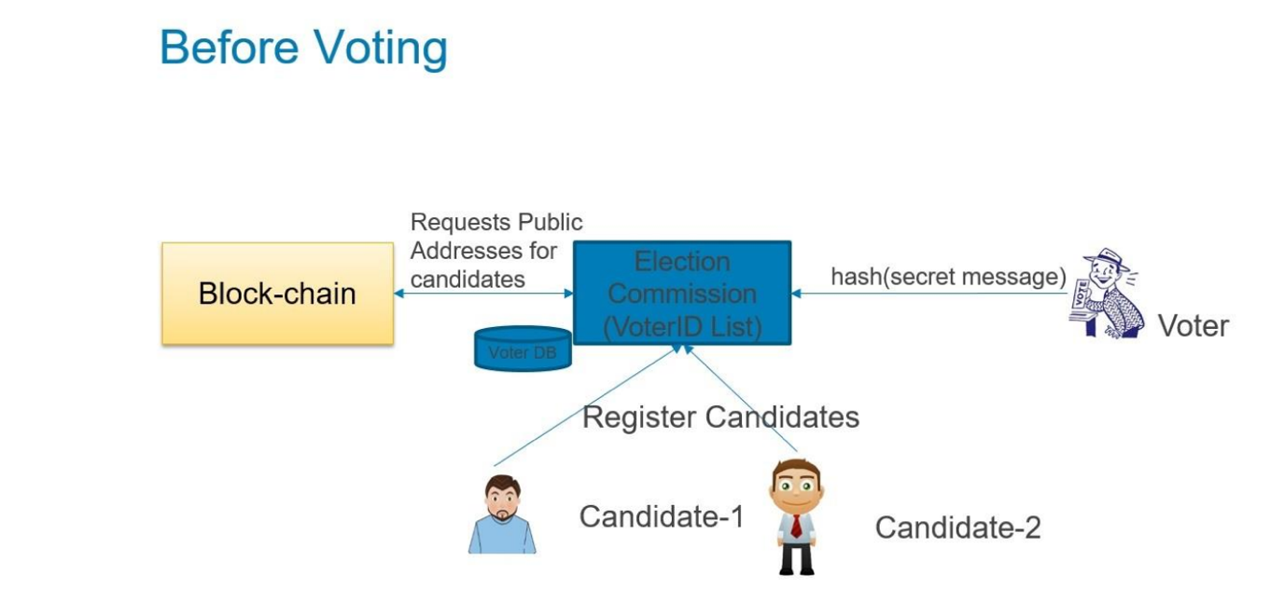

**Voting Process:**

* The system should facilitate fair and transparent elections.
* Voters should be able to cast their votes securely and anonymously.
* Double voting or any fraudulent activities should be prevented.

**Real-time Updates:**

* The system should provide real-time updates on voting progress and results.
* Voters should be able to track the status of their votes and overall election progress.
* Data Analysis:
* Requirements were analyzed and categorized into functional and non-functional requirements based on their importance and feasibility.

#### 3.6.1.1 Functional Requirements:

**Functional requirements for Voters:**

* **Register to Vote**: Voters should be able to register securely with proper verification mechanisms.
* **Login with MetaMask**: Voters should be able to log in securely using their Ethereum addresses via MetaMask.
* **Cast Vote**: Voters should be able to cast their votes securely and anonymously.
* **View Election Information**: Voters should have access to election details such as candidate lists and voting deadlines.

#### 3.6.1.2 Functional requirements for Administrators:

* **Administer Voter Registration**: Administrators should be able to manage the voter registration process, including approving or rejecting voter registrations.
* **Create and Manage Elections**: Administrators should be able to create new elections, set start and end times, and manage candidate lists.

#### 3.6.1.3 Non-functional Requirements:

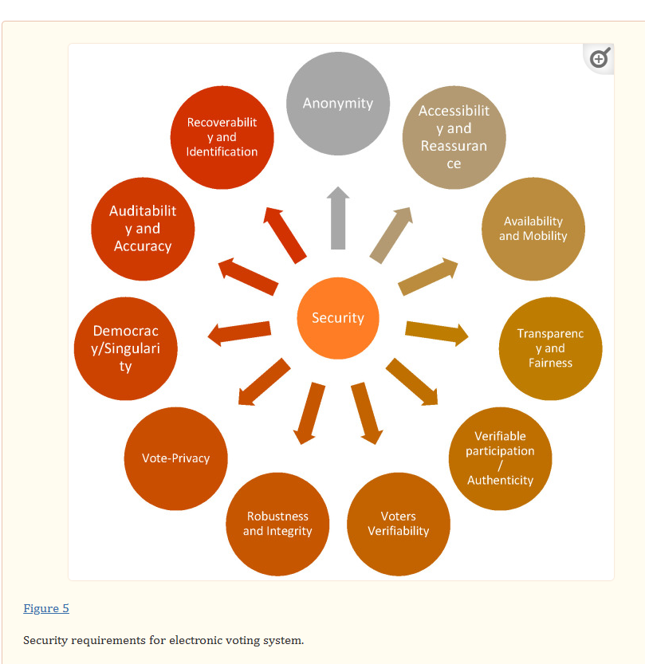

1. **Security:**

* Implement robust security measures to protect voter data and prevent unauthorized access.
* Ensure encryption of sensitive information and secure communication channels.

1. **Reliability:**

* Ensure the system is available and reliable throughout the entire election period.
* Implement backup and recovery mechanisms to handle system failures.

1. **Usability:**

* Design the system to be user-friendly and accessible to voters with varying technical skills.
* Provide clear instructions and intuitive interfaces to guide users through the voting process.

1. **Scalability:**

* Ensure the system can handle a large volume of voters and votes without compromising performance.
* Design the system architecture to scale horizontally or vertically as needed.

1. **Performance:**

* Optimize system performance to handle peak loads during elections.
* Minimize response times for vote casting and result updates.

### 3.6.2 Feasibility Study

This feasibility study evaluates the technical, operational, and economic feasibility of the voting system.

**Technical Feasibility:**

* Utilize blockchain technology for secure and transparent voting.
* Use smart contracts to ensure the integrity of the voting process.
* Implement Web3.js or Ethers.js libraries for interaction with the blockchain.

**Operational Feasibility:**

* Design the system to be user-friendly, with clear instructions and intuitive interfaces.
* Provide training and support programs to ensure successful adoption by voters and administrators.

**Economic Feasibility:**

* Assess the initial development costs and long-term benefits of increased transparency and trust in the electoral process.
* Consider the cost-effectiveness of utilizing blockchain technology and cloud infrastructure for system implementation and maintenance.

## 3.7 System Design

The system design phase translates the identified requirements into a detailed technical specification of the Decentralized Students e-Voting System. This section presents the system architecture, data flow diagrams, and user interface designs.

### 3.7.1 System overview

The System Overview Diagram provides a high-level view of the major subsystems or components within the Voting System and their interactions.

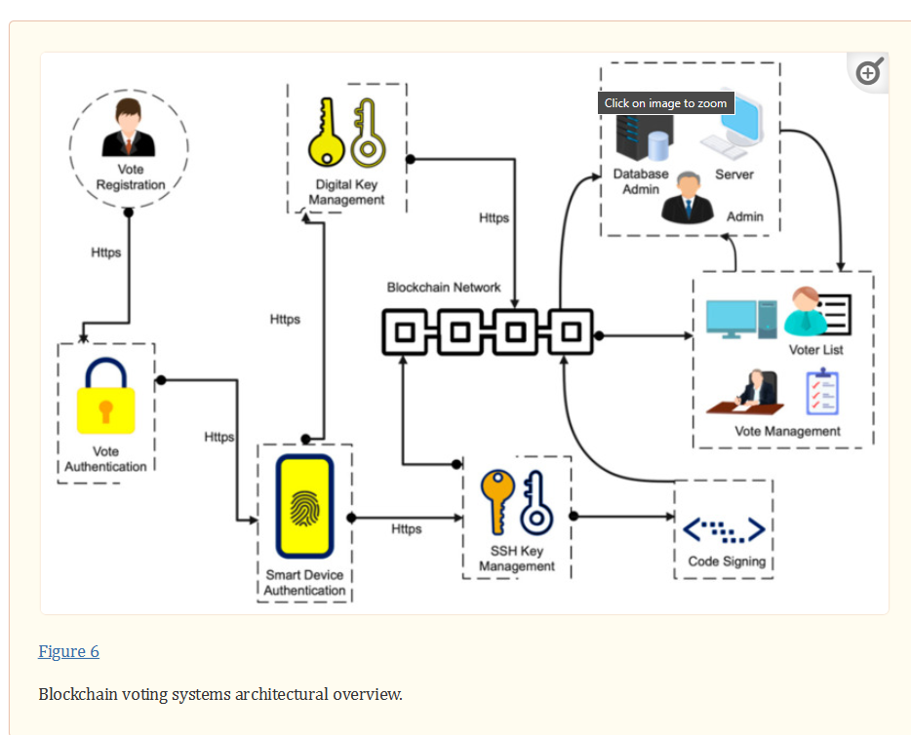

### 3.7.2 System Design Architecture

The system architecture combines the Ethereum blockchain, smart contracts, and a web-based front end. The key components are:

* Ethereum Blockchain: Provides a decentralized, immutable, and transparent platform for recording votes and election data.
* Smart Contracts: Implement the voting logic, enforce election rules, and manage voter registration, candidate nomination, and vote tallying.
* Web Frontend: Serves as the user interface for voters and election administrators to interact with the system.

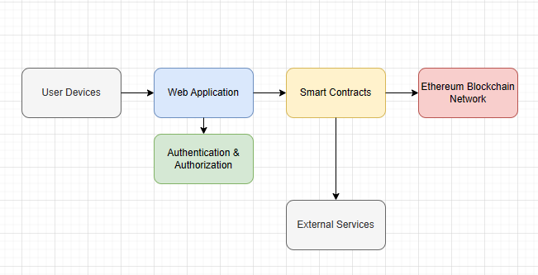

### 3.7.2 Smart Contract Design

The backbone of the voting system is a smart contract deployed on a blockchain network. The smart contract is responsible for managing various aspects of the voting process, including voter registration, candidate management, and vote casting.

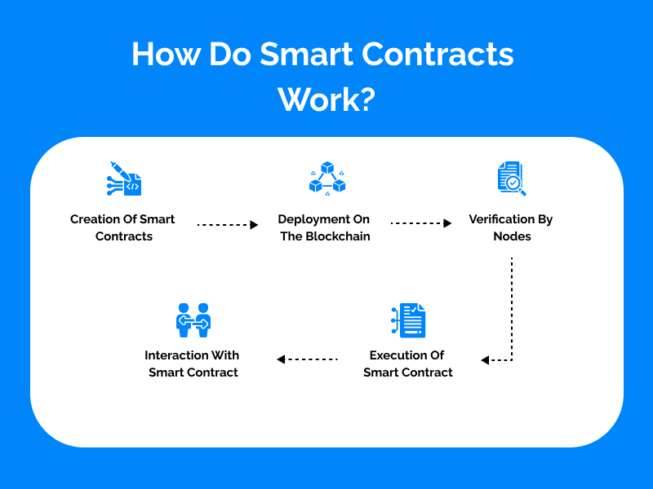

Let's examine the key components of the smart contract of voting system:

**Voter Registration**: The smart contract includes functions to facilitate voter registration. Voters can submit their details, including their Ethereum addresses, which are then stored securely on the blockchain. Additionally, the contract implements mechanisms to verify and authenticate voter registrations, ensuring the integrity of the electoral process.

**Candidate Management**: The smart contract provides functionalities for managing candidates participating in the election. Election administrators can add, remove, and update candidate information through designated functions. Each candidate is assigned a unique identifier and their relevant details are stored on the blockchain.

**Election Lifecycle Management**: The smart contract governs the lifecycle of the election, including the start and end times of voting periods. Election administrators can set the start and end times through specific functions, ensuring that voting is conducted within predefined periods to maintain fairness and transparency.

**Vote Casting:** Eligible voters can cast their votes through the smart contract. The contract records each vote securely on the blockchain, ensuring that votes are tamper-proof and immutable. Additionally, the contract prevents double voting by implementing mechanisms to detect and reject duplicate votes.

**Result Tabulation**: As votes are cast, the smart contract tabulates the results in real-time. The contract updates vote counts for each candidate, providing election administrators and voters with transparent access to voting results throughout the election process.

**Access Control**: The smart contract incorporates access control mechanisms to regulate interactions with different functions. Only authorized individuals, such as election administrators, can perform administrative functions such as candidate management and election lifecycle management.

### 3.7.3 Integration with User Interface

Here we will use Reactjs to create the user interfaces to interact with the smart contract.

For this to happen we, will use etherjs to connect the UI and the smart contract

The smart contract is seamlessly integrated with the user interface of the voting system, allowing voters and election administrators to interact with the contract's functionalities through intuitive graphical interfaces. The user interface provides streamlined access to key features such as voter registration, candidate management, and vote casting, enhancing the user experience and accessibility of the voting system.

### 3.7.4 Integration with ethers.js

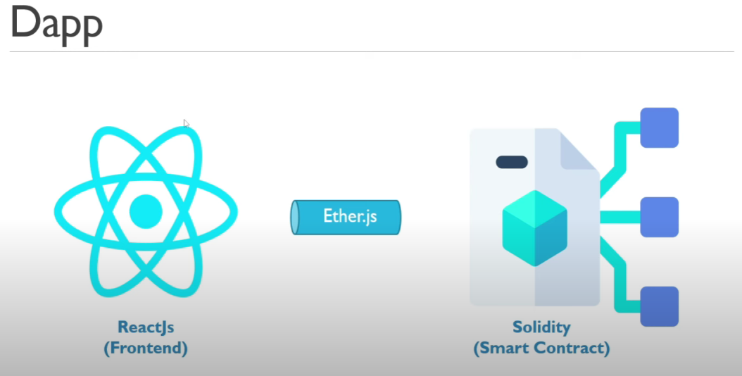

**Ethers.js** plays a crucial role in facilitating the interaction between users and the Ethereum blockchain, enabling seamless communication with the smart contract deployed for the voting system. Let's explore the key aspects of integrating ethers.js into the voting system:

**Web3 Provider** Initialization: Ethers.js provides utilities for initializing a Web3 provider, which serves as the bridge between the frontend application and the Ethereum blockchain. By connecting to a suitable Ethereum node, such as Infura or a local node, the Web3 provider enables the frontend to interact with the blockchain.

**Smart Contract Abstraction**: Ethers.js simplifies the process of interacting with smart contracts by providing tools for generating contract abstractions. These abstractions encapsulate the functionality and data structures of the smart contract, exposing intuitive JavaScript objects that can be used to invoke contract functions and retrieve contract state.

**Contract Deployment:** Ethers.js enables the deployment of smart contracts directly from the frontend application. Developers can use Ethers.js to compile Solidity smart contracts, deploy them to the Ethereum blockchain, and obtain references to the deployed contract instances for further interaction.

**Transaction Handling**: Ethers.js facilitates the creation and submission of transactions to the Ethereum blockchain. Users can use Ethers.js to construct transactions for actions such as casting votes or updating contract state, sign transactions with their private keys, and broadcast them to the network for execution.

**Event Listening**: Ethers.js provides utilities for listening to events emitted by smart contracts. By subscribing to contract events, frontend applications can receive real-time notifications of important contract state changes, such as the casting of votes or the declaration of election results.

**Wallet Integration**: Ethers.js seamlessly integrates with Ethereum wallets, such as MetaMask, enabling users to sign transactions and interact with the voting system securely. Users can connect their Ethereum wallets to the frontend application, allowing them to cast votes and perform other actions with ease.

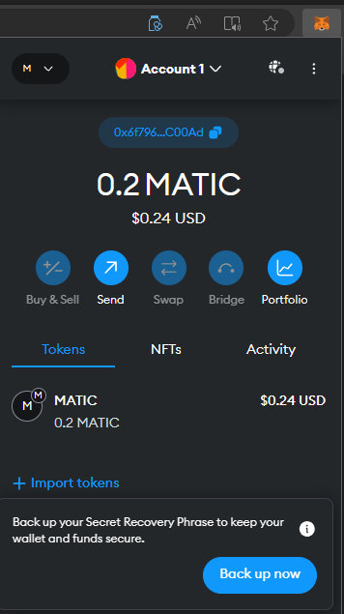

Figure showing MetaMask integration

*Voting process on the Ethereum network*

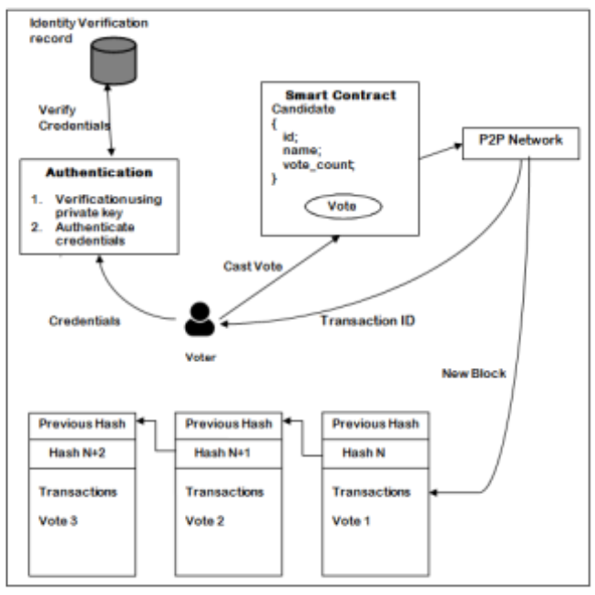

### 3.7.5 Use Case Model

The use case model describes the interactions between actors (users or external systems) and the voting system. It outlines the various actions that users can perform and the system's responses to those actions. Below are the primary actors and their corresponding use cases:

**Actors**:

**Voter:** Individuals who are eligible to participate in the voting process.

**Election Administrator**: Individuals responsible for managing and overseeing the election process.

**USE CASE MODEL**

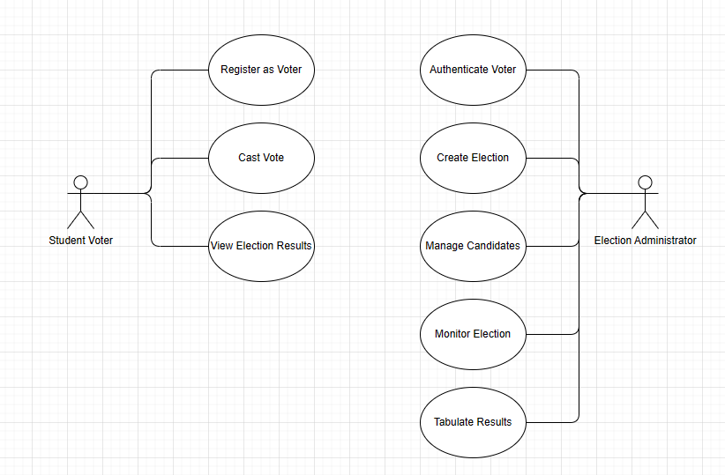

### 3.7.6 Data Flow Diagram

Data Flow Diagrams (DFDs) illustrate how data moves through the system and the transformations it undergoes. The DFDs for the Decentralized Students e-Voting System include:

* Context Diagram (Level 0 DFD): Shows the system's interactions with external entities.
* Level 1 DFD: Decomposes the system into main processes and data stores.

**Context Diagrams**

**Level 0 DFD**

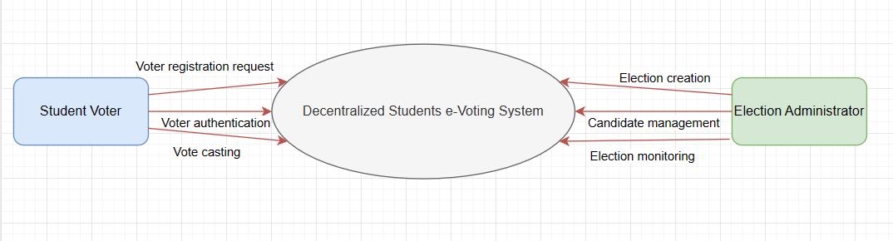

**Level 1 DFD**

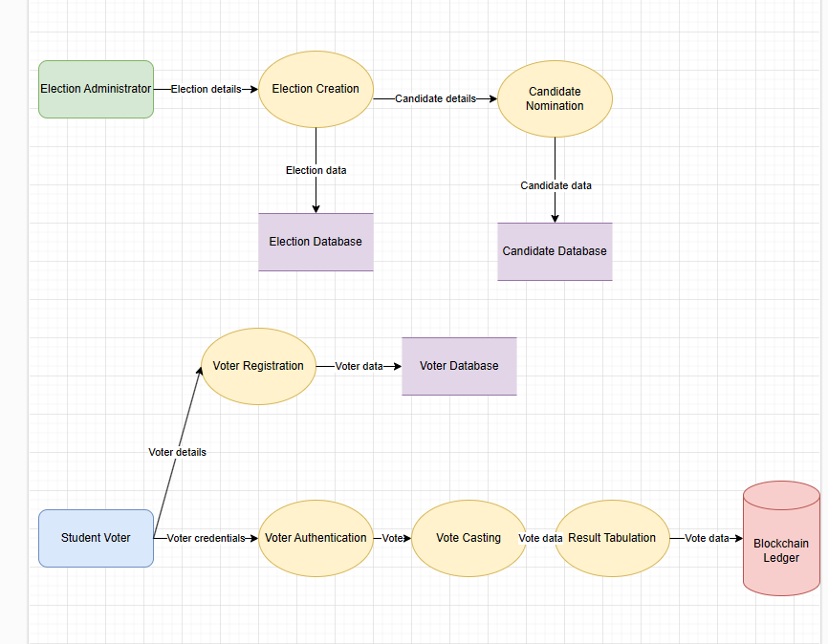

### 3.7.7 DATA FLOW DIAGRAM

Data Flow Diagram (DFD):

The Data Flow Diagram (DFD) illustrates the flow of data and transactions within the Voting System, including the external entities, processes, and data stores involved.

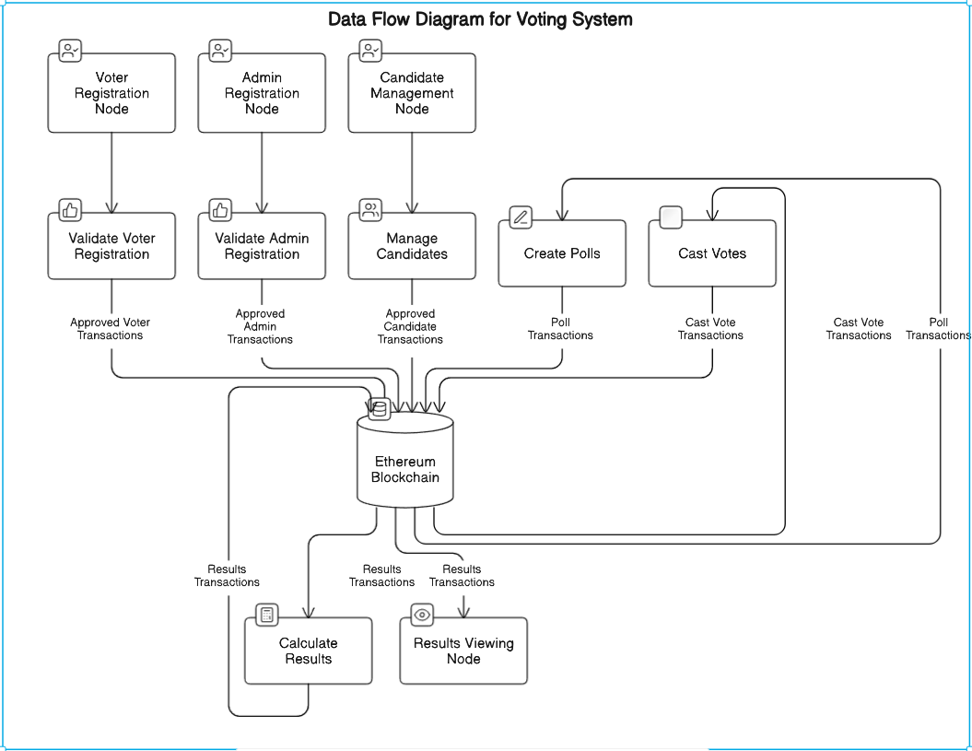

In the DFD for our blockchain-based voting system, the external entities are "Voter Registration Node," "Admin Registration Node," and "Candidate Management Node." These entities interact with the system through various processes, such as "Validate Voter Registration," "Validate Admin Registration," and "Manage Candidates." The validated transactions are recorded on the Ethereum Blockchain, which acts as the central data store.

The DFD also depicts processes like "Create Polls," "Cast Votes," and "Calculate Results," which interact with the Ethereum Blockchain to manage poll data, record cast votes, and generate election results. The "Results Viewing Node" external entities allow voters and admins to view the election results by reading the transactions from the blockchain.

### 3.7.8 System Flowchart

**System Flowchart:**

The System Flowchart illustrates the flow of control and sequence of actions within the Voting System, including decision points and loops.

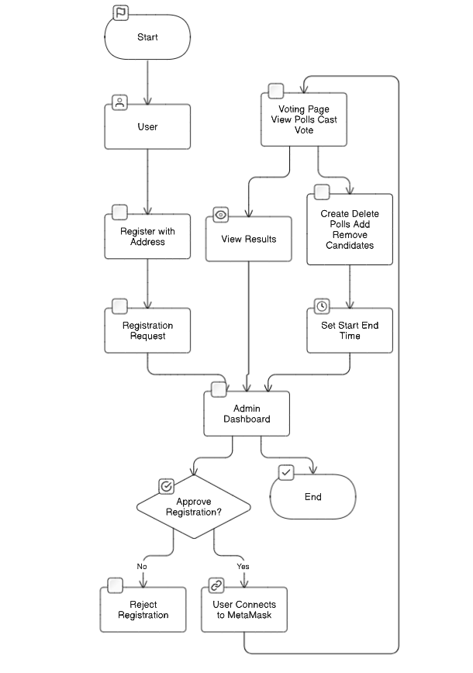

In the System Flowchart for our blockchain-based voting system, the process starts with the user registering with their address. The registration request is sent to the Admin Dashboard, where the admin can approve or reject the registration. If approved, the user can connect to MetaMask and access the Voting Page to view polls and cast their vote.

The flowchart also depicts the admin functionalities, such as creating/deleting polls, adding/removing candidates, viewing results, and setting the start/end time for the election. These actions are performed through the Admin Dashboard, which interacts with the relevant components of the Voting System.

3.8 User Interfaces

3.8.1 Home Page(Landing Page)

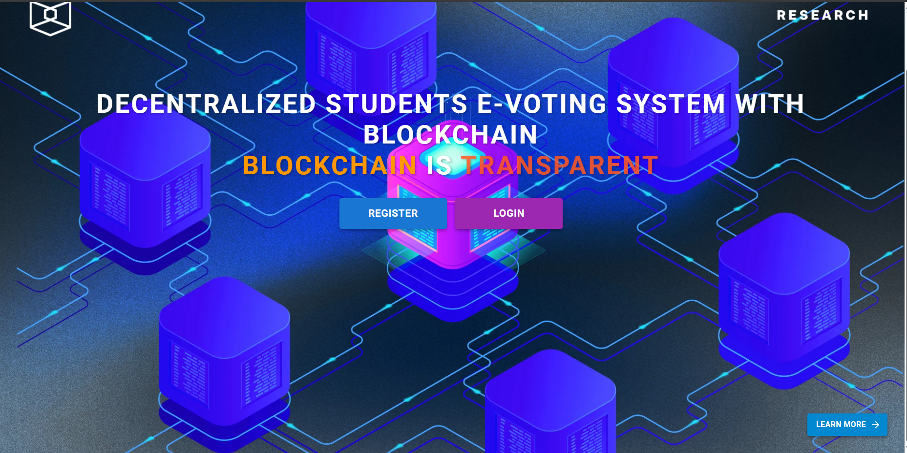

This is the entry point when the web application starts and contains:

1. System title
2. Register button

Login button

1. Learn more button- This takes the user to a page where they can learn more about the system. It contains educational resources about blockchain, cryptography, and Ethereum and frequently asked questions that the user may have.

3.8.2 Login Page

The login page serves as the entry point for users to access the Decentralized Students e-Voting System. It provides a simple and intuitive interface for users to connect their MetaMask wallets and authenticate themselves.

1. **Login**

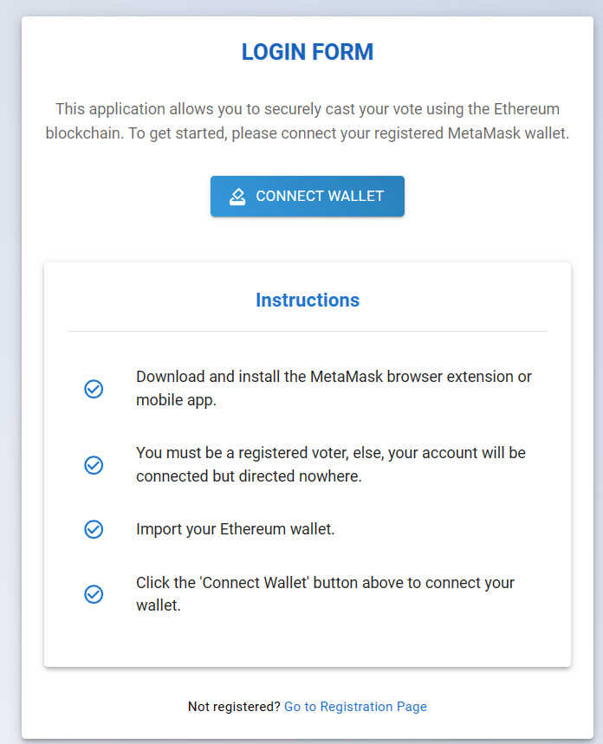

1. **Connecting an account using metamask**

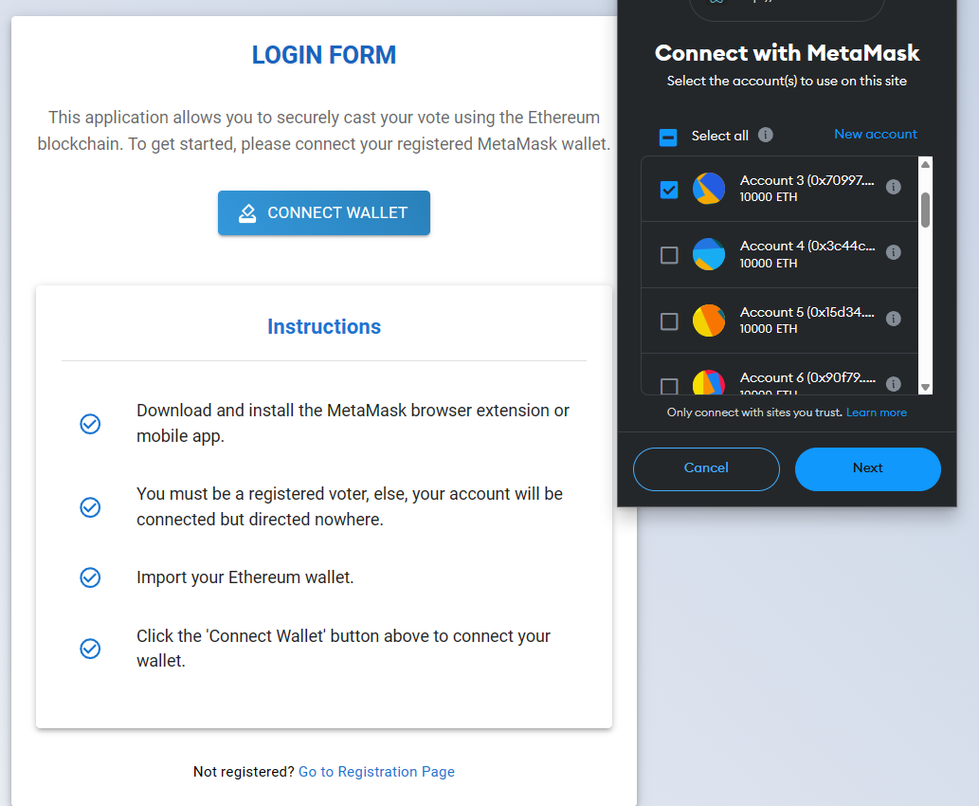

Here, you choose your address, click on next and you will be connected and directed to the intended page; either admin or voter page

1. **An unidentified user trying to log in:**

In this case, as instructed, they will be taken nowhere. Their connected account details are displayed (Their public address) and an option to disconnect

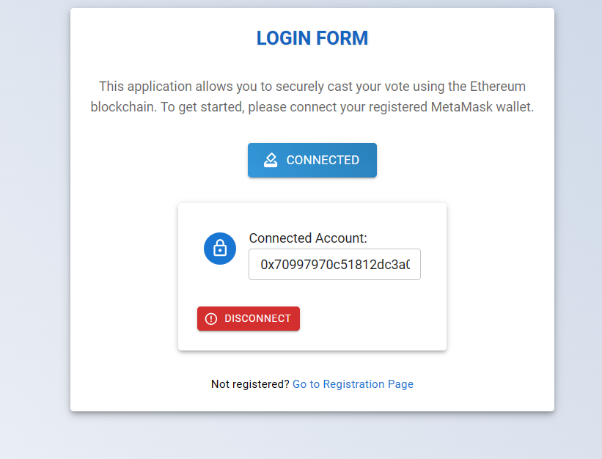

1. **Admin Successful login:**

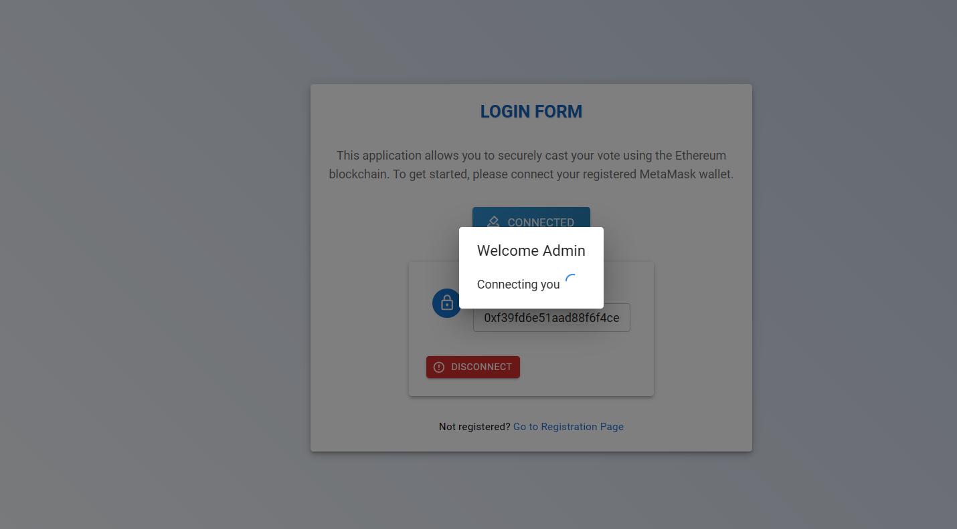

1. **Voter successful login**. The system is able to identify who is logging in. As you can see, an approved voter called Ann Marai is logging in.

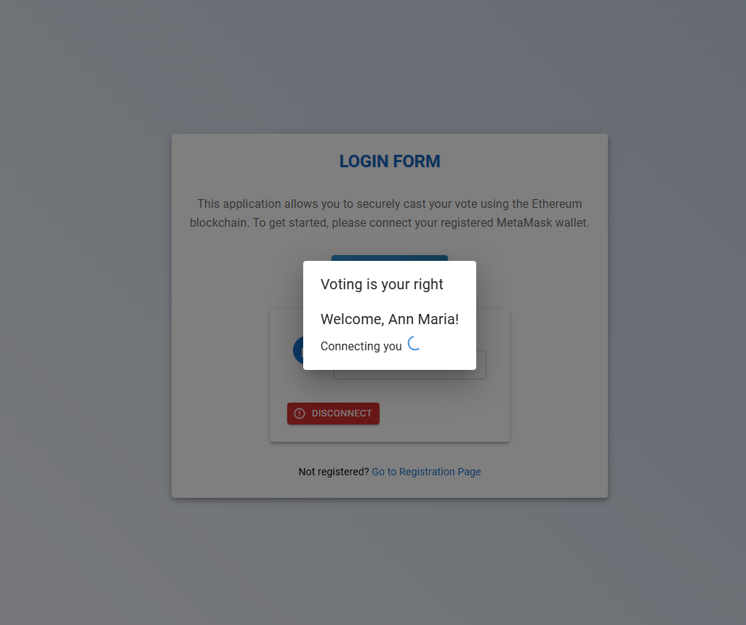

The login page includes the following components:

1. Application title and logo
2. Welcome message and brief instructions
3. "Connect Wallet" button to initiate MetaMask connection
4. Connected account information and "Disconnect" button (displayed after successful connection)
5. Instructions for setting up MetaMask and connecting the wallet
6. Link to the Voter Registration page for unregistered users

3.8.3 Voter Registration Page

The voter registration page allows eligible students to register themselves as voters in the system. It captures essential voter information and associates it with their MetaMask wallet address.



The voter registration page consists of the following elements:

1. The page title and navigation back to the login page
2. Connect the Wallet button to establish MetaMask connection
3. Registration status indicator (Approved, Pending, or Not Registered)
4. Registration form with input fields for first name, last name, registration number, email, and phone number
5. Register button to submit the registration form
6. Links to the Login page and Candidate Registration page
7. Below, the form shows the Registration status at the top. After connecting the address, the system identifies that the user is not registered and asks them to do so.

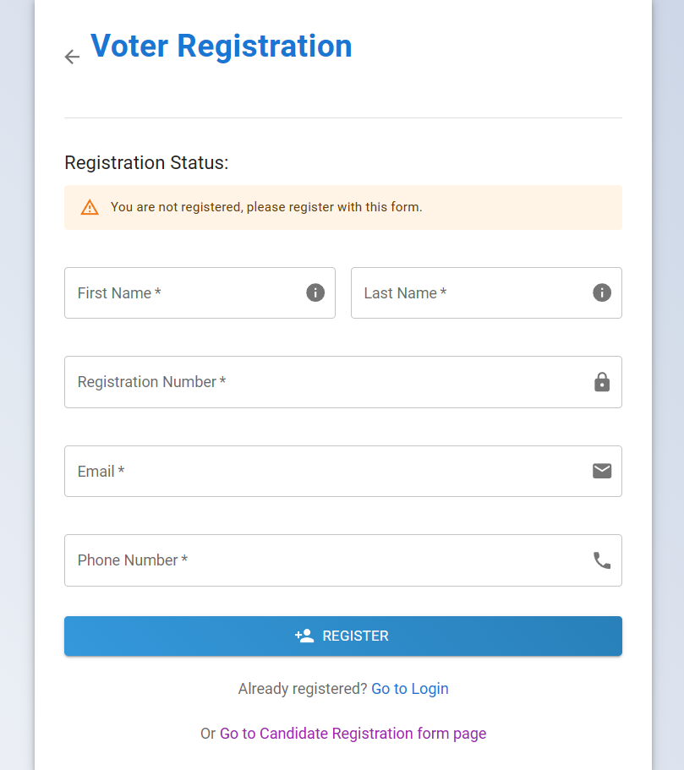

1. Status showing that the user is registered and awaiting approval from the admin. (indicated with blue arrow)

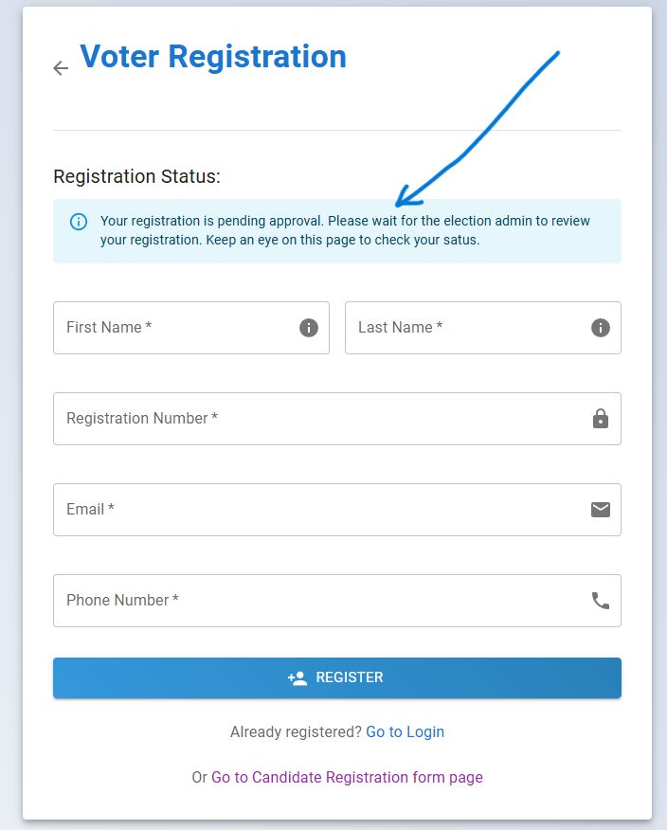

1. Approved voter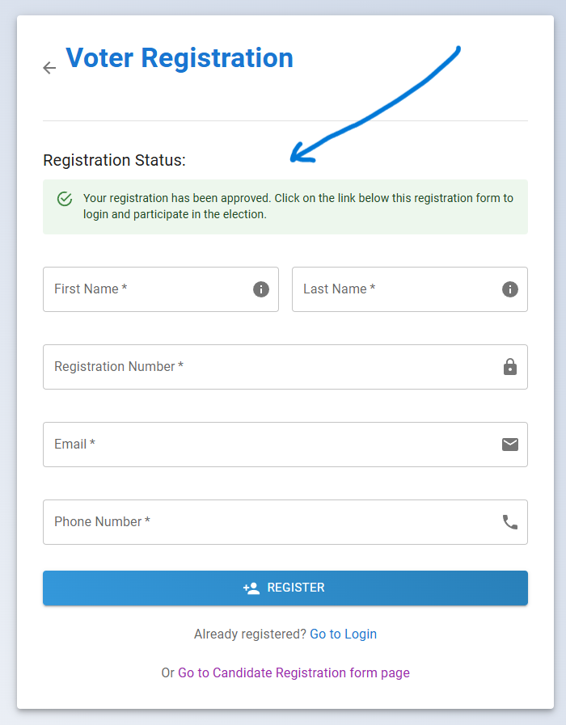

**2. A user trying to register after an election has started**

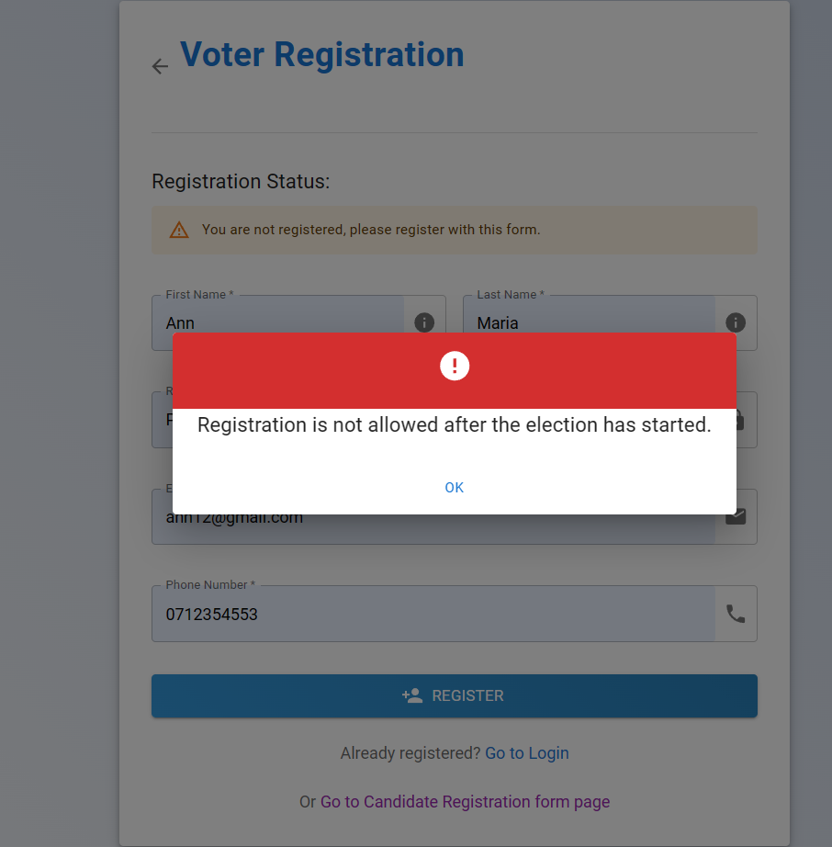

3.8.3 Admin Dashboard

The admin dashboard serves as the central hub for election administrators to manage various aspects of the voting system. It provides an overview of key metrics and quick access to essential functionalities.

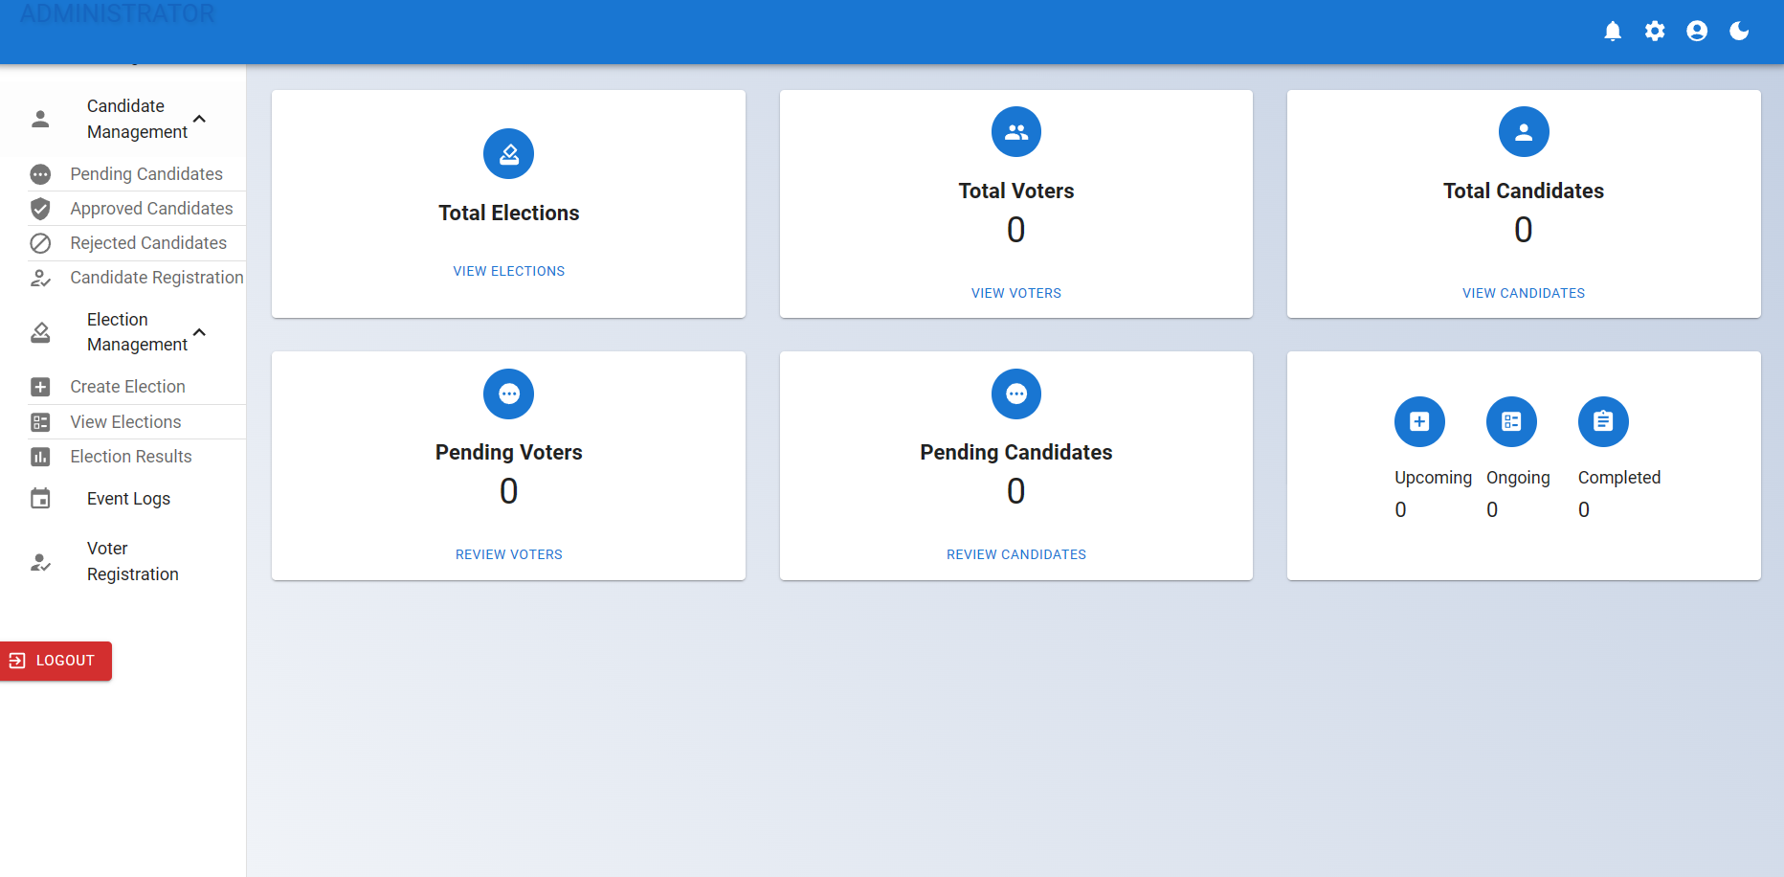

The admin dashboard includes the following components:

1. Navigation menu with options for voter management, Candidate Management, Election Management, Event Logs, and Voter Registration
2. Quick stats cards displaying total elections, total voters, total candidates, pending voters, pending candidates, and election progress
3. Dark mode toggle button
4. Logout button

3.8.5 Election Creation Page

The election creation page enables election administrators to create new elections, define positions, and manage existing elections. It provides a streamlined interface for setting up and configuring elections.

The election creation page includes the following components:

1. The page title and navigation buttons (Home, Election Details, Events)
2. Election creation form with input fields for election name, start time, and end time
3. Create an Election button to add a new election
4. Expandable list of created elections with details such as start time, end time, positions, and actions (Create Position, Extend Election)
5. Form to create an election

It contains:

1. Election Name
2. Start Date
3. End Date



1. An election named SSSANU ELECTIONS 2024 was created

It shows

1. Election name (SSSANU ELECTIONS 2024)
2. Start and end time(11:02 am to 11:10 am)
3. Button to add positions to an election
4. 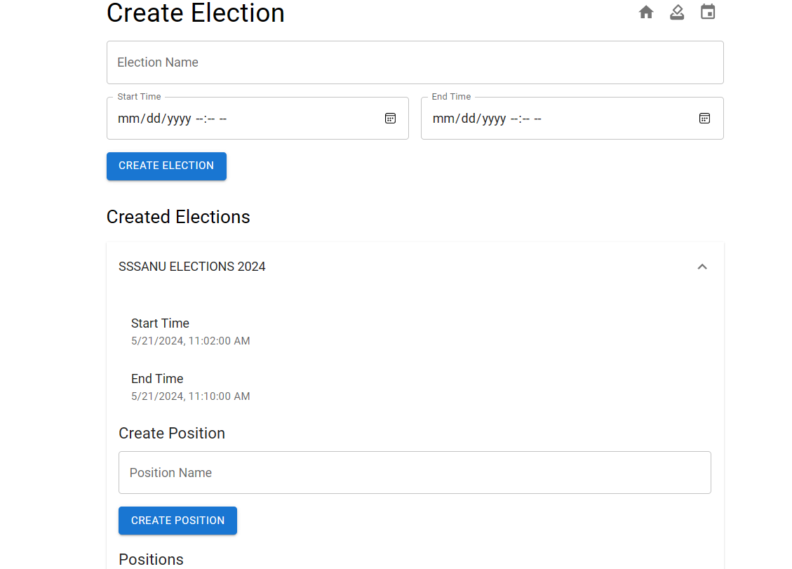

3. After positions have been created:

You can now see the created positions that have been added to an election(SSSANU ELECTIONS 2024) and candidates can register for i.e PRESIDENT and SECRETARY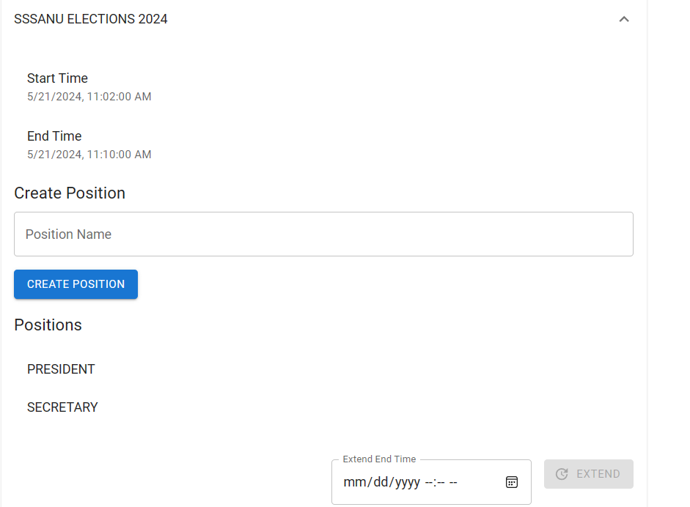

1. Extending an election

BEFORE: You can see that an election called (UON STUDENTS GENERAL ELECTION is to end at 12:35 pm

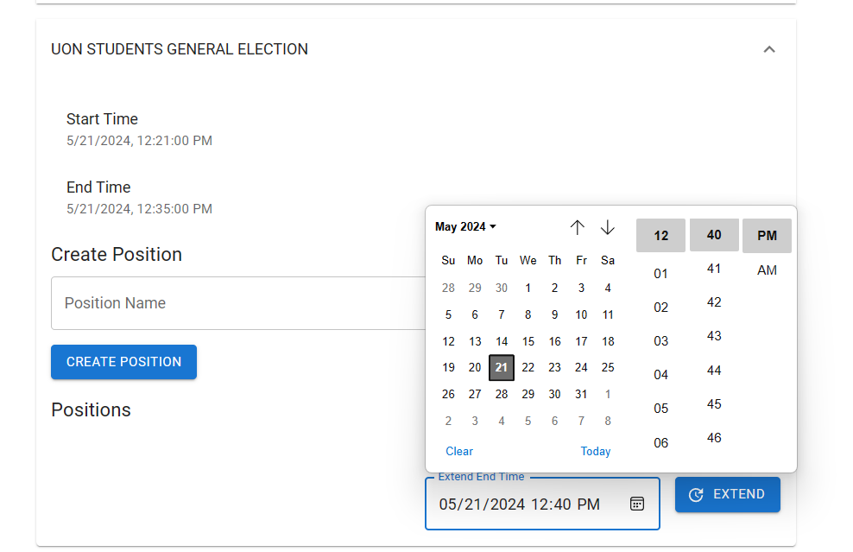

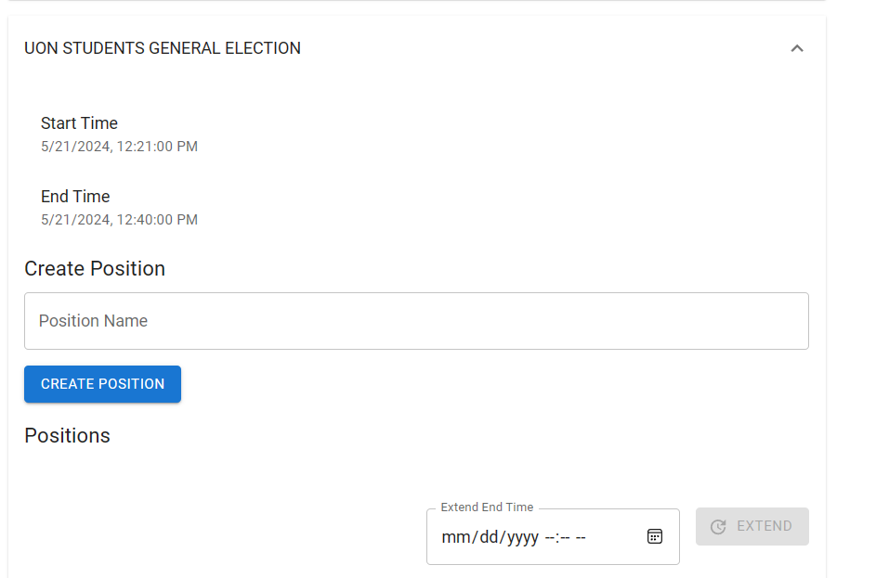

Fig 3.8.4: Showing AFTER: The election end time has been extended from 12:35 pm to 12:40 pm

3.8.5 Election Details Page

The election details page allows voters to view information about a specific election, select candidates for each position, and cast their votes. It provides a user-friendly interface for voters to participate in the election process.

The election details page consists of the following elements:

1. Election name and navigation buttons (Home, Election Results, Events)
2. Election start and end time chips
3. Countdown timer and progress bar indicating the remaining time
4. Vote Now button (enabled only during the ongoing election period)
5. Positions and candidates section with radio buttons for candidate selection and approval rating sliders
6. Cast Vote button to submit the selected candidates
7. Dialogs for displaying position details and candidate information

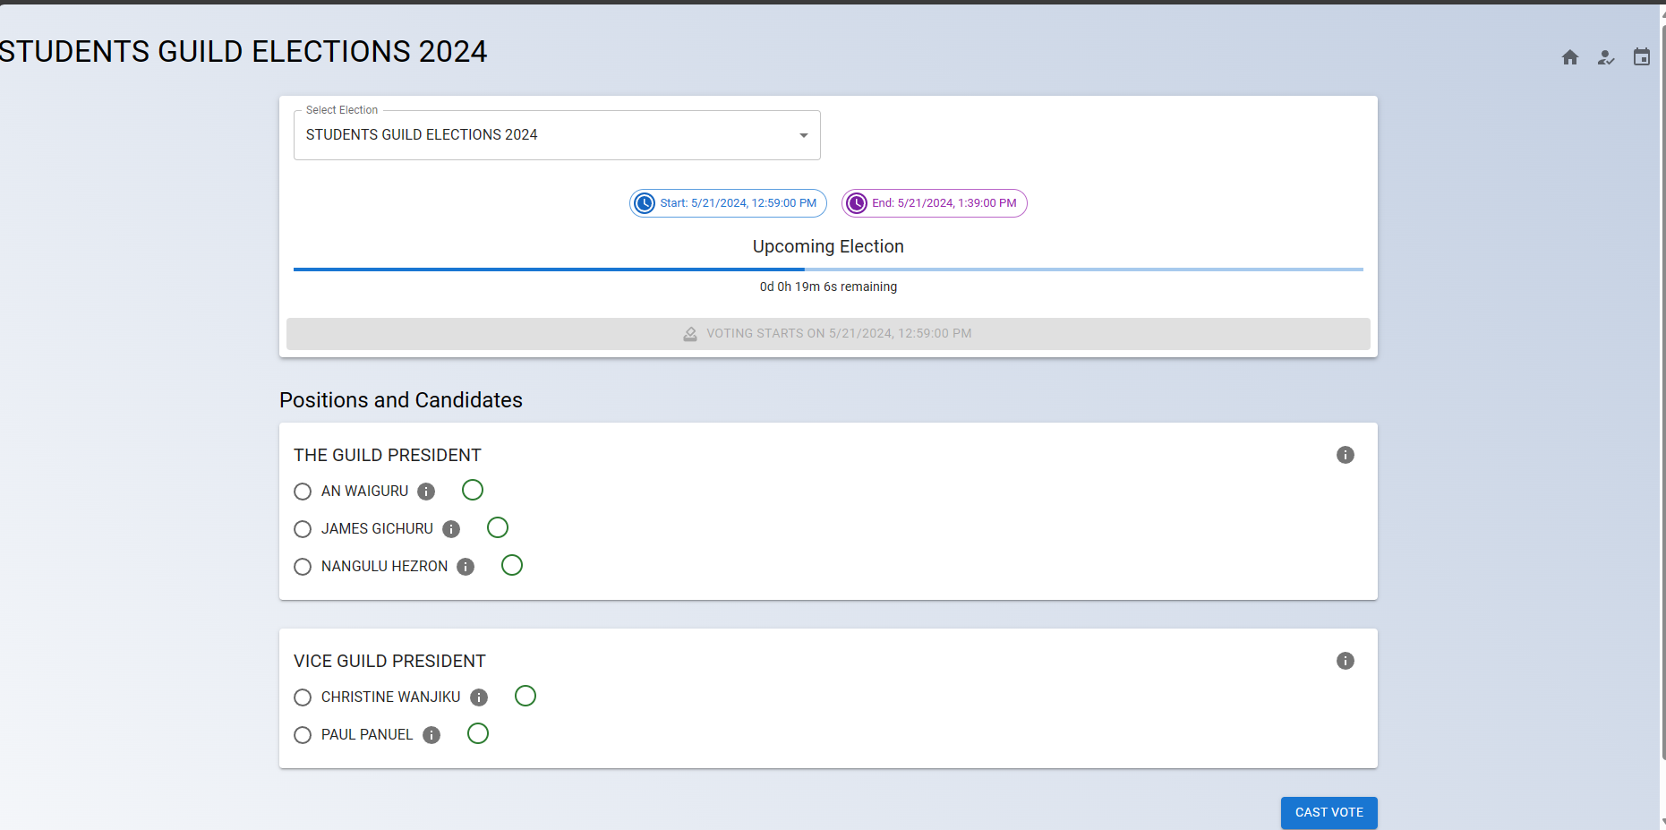

Fig 3.8.5.1: Showing the voting page

Above, you can see a dialog box called “Select election”. From the dg box, a user selects an election to see its details. In our case, we selected an election called STUDENTS GUILD PRESIDENT ELECTIONS 2024 with all its details displayed including the start and end time, a blue bar counting down the start time, positions and candidates that are vying for them, and the button to cast your vote after you have selected your preferred candidate in each position.

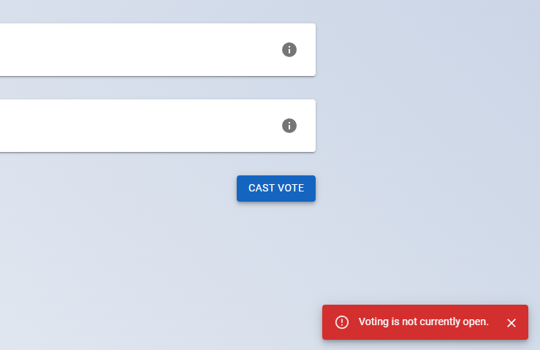

Fig 3.8.5.2: Showing a voter being denied voting when they try to cast their vote before the electron is opened

3.8.6 Election Results Page

The election results page provides a comprehensive overview of the voting results for each election. It displays the election details, voting distribution, and a breakdown of votes for each candidate in a user-friendly and visually appealing manner.

Figure 3.8.6: Election Results Page

The election results page consists of the following components:

* Page title and navigation buttons (Home, Elections, Events)
* Grid of election cards displaying the name, positions, and a random image for each election
* Expandable accordion for each position in the selected election, containing:
  + Voting Results table with candidate names, vote counts, and percentages
  + Total votes and winner(s) for the position
  + Voting Distribution pie chart visualizing the share of votes for each candidate
  + Votes Breakdown bar chart displaying the number of votes for each candidate

The election cards are clickable, allowing users to select a specific election and view its detailed results. The results are dynamically fetched from the smart contract and presented in a clear and concise format.

The Voting Results table provides a tabular view of the candidates, their received votes, and the percentage of total votes. It includes visual indicators such as avatars and progress bars to enhance readability and comparability.

The Voting Distribution pie chart offers a visual representation of the share of votes each candidate has received. It helps users quickly grasp the relative popularity of candidates within a position.

The Votes Breakdown bar chart displays the absolute number of votes for each candidate, allowing users to compare the vote counts directly.

The Election Results page is designed to be responsive and adaptable to different screen sizes, ensuring a seamless user experience across devices.

* 1. **PROJECT PLAN**

